Lab 6: Adding Memory & Bootstrapping Circuit

CSEE 4280 – ADVANCED LOGIC DESIGN
SPRING 2018

(20 pts) Prelab Due: Feb 16, Friday 1:30 PM

(30 pts) Demo Due: Feb 23, Friday 4:30 PM

(50 pts) Report Due: March 1, Thursday 5 PM

Total Points: 100

In the previous labs you built a processor. It can execute instructions defined as long as we don’t have to access the memory — the processor you built so far has no memory. In this lab, we will include a Random Access Memory (RAM) and a Read Only Memory (ROM) memory for our processor. Once we put everything together, we can load our processor design onto the Xilinx FPGA board. After that, you can write any simple program in machine code, load it into your processor, and execute the program on the Basys2 board.

Excited? Let’s start!

Components to be included (find them on ELC):

- ROM array
- RAM array

Components to be built:

- Memory bootstrapping

After we build these components, we will incorporate our memory implementation into our toy processor. Certainly there will be some modifications to the toy processor. It is a good idea to double check that the toy processor you have so far is bug-free.

This is a lab that requires you to start custom designing certain components. It will be interesting but also challenging, and it will take longer time and more effort. Please plan ahead and work together. It is really important to carefully read and understand this lab instruction before you start.
Part 1
Include ROM

Note: This is the part where we use ROM and RAM to store information (program for our processor). Our processor accesses RAM (random access memory) during program execution. However, power is always needed to maintain information stored in RAM. Therefore, these information (program) needs to stay in ROM (Read only memory), which doesn't need power, before program execution. The program in ROM will be loaded into the RAM at the very beginning of execution. During program execution, RAM is also needed for information storage (e.g., STORE instruction). Below we will design ROM and RAM arrays for our processor.

- Extract the ROMRAM.zip. Copy all the files into your project directory.
- Open your toy processor project, use Project → ADD Source to add the following schematic.
  - encode8.sch
  - enoutput8_sch.sch
  - bus8_mux.sch
  - ROM_array.sch
  - RAM_array.sch
Note: Please make sure you include the schematics in order.
- Open all the schematics to check them.

- Here is the ROM_array.sch.
INIT=00000000
INIT=00100000
INIT=00100000
INIT=00080000
INIT=00050000
INIT=00105501
INIT=00005050

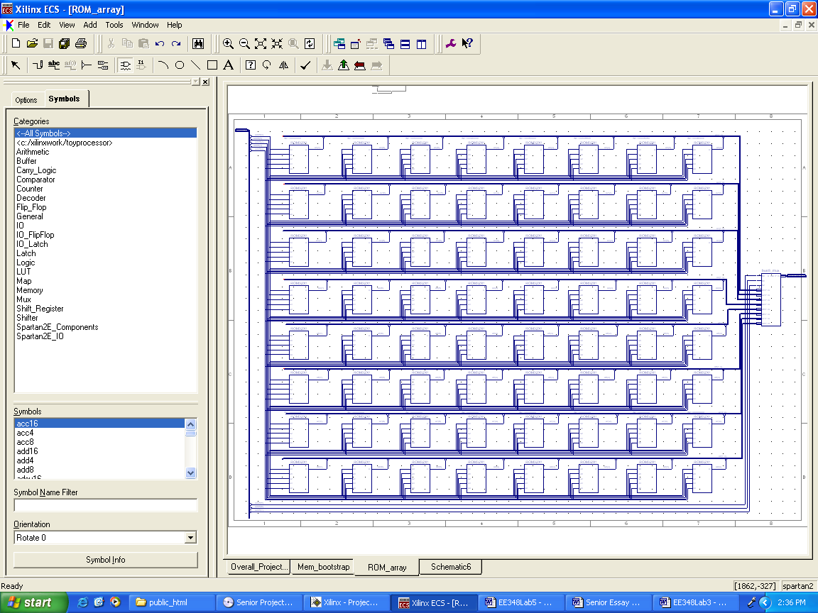
ADDR(7:0)
ADDR(0)
ADDR(4)
ADDR(5)
ADDR(7)
A8(7)
A8(5)
A1(7)
A1(0)
A8(0)
DATA_OUT(7:0)
INIT=0006EEEE
bus8_mux
Full view of the ROM array

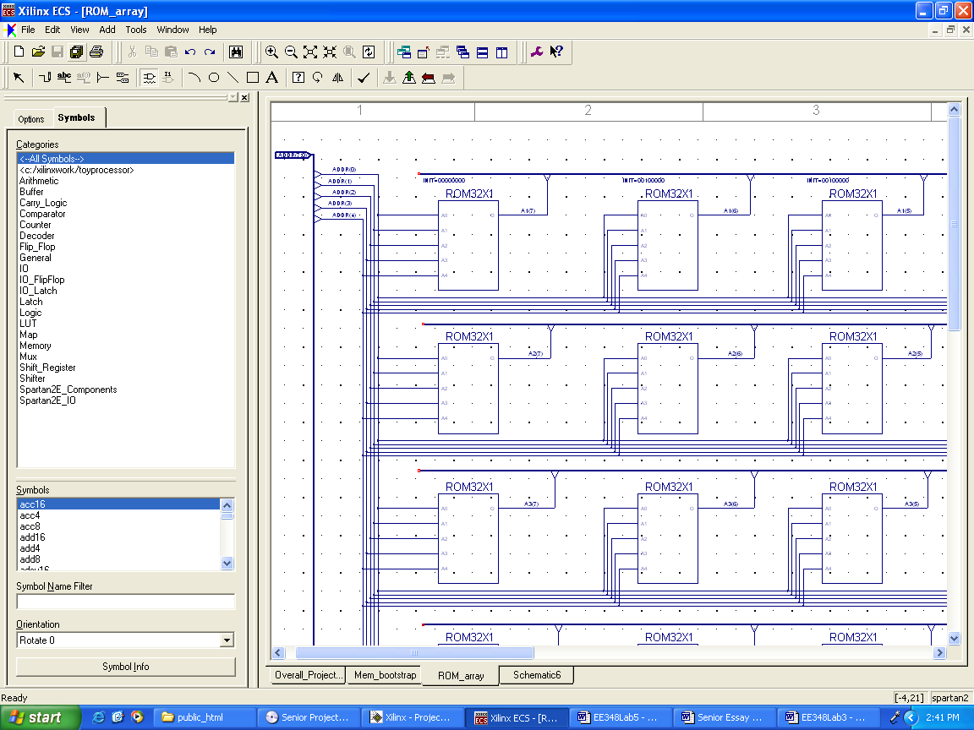
Partial view of ROM array

Note: The higher 3 bits of the 8 bits sent to the ROM array are used to select which row of data to use. The lower 5 bits are used to select among the 32 locations in this row.

- Create a symbol for your ROM array.
- (Demo 5 pts) Create a test bench waveform to check the correctness of your design. You must figure out a way to verify that the ROM is working. To initialize a ROM module, double-click on it, and set a value in the INIT field. This tells the ROM the value it should output for each given input. The least significant bit of the value is what the ROM will output when the input is 00000. The most significant bit is what the ROM will output when the input is 11111. Since the value is entered in Hexadecimal, you will need 8 hex digits to tell the ROM what to do for each of the 32 possible input values. (Please take time to study and understand how ROM works before you start to testbench).
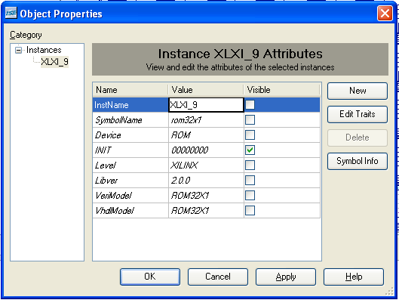

Part 2
RAM

The design principle for the RAM array is almost the same as the one for the ROM array. The difference is that in each row of RAM array, there is only one 8-bit wide RAM unit.

- Here is the schematic for RAM_array.
DATA_IN(7:0)
WE
CLK
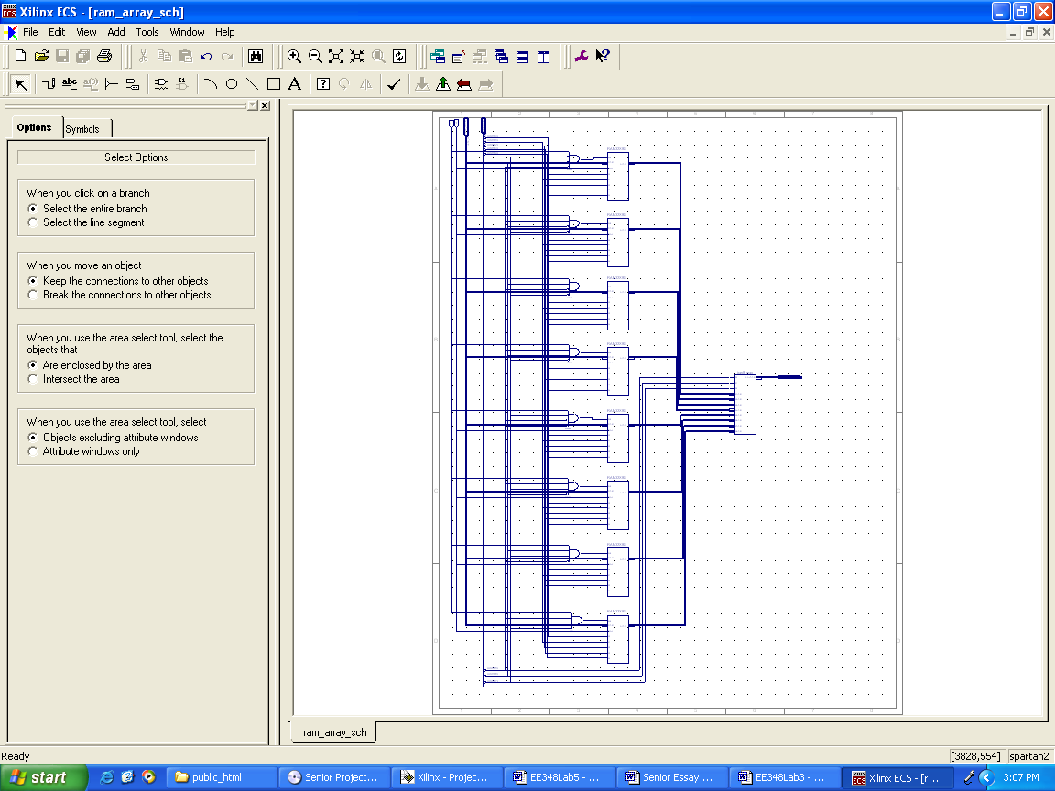
ADDR(7:0)
ADDR(0)
ADDR(4)
AND4B3
RAM32X8S
AND4B2
AND4B1
AND4B2
AND4B1
AND4B1
AND4
ADDR(5)
ADDR(7)
bus8_mux
DATA_OUT(7:0)
AND4B2
Full view of the RAM array
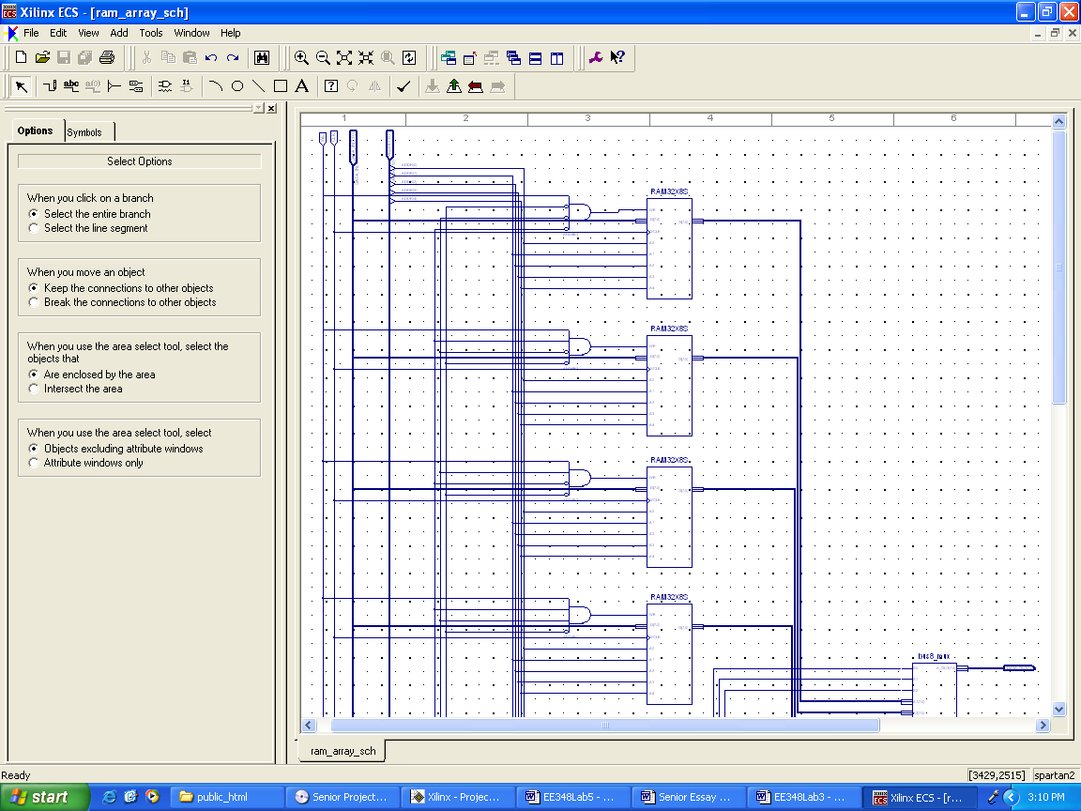
Top half of the RAM array
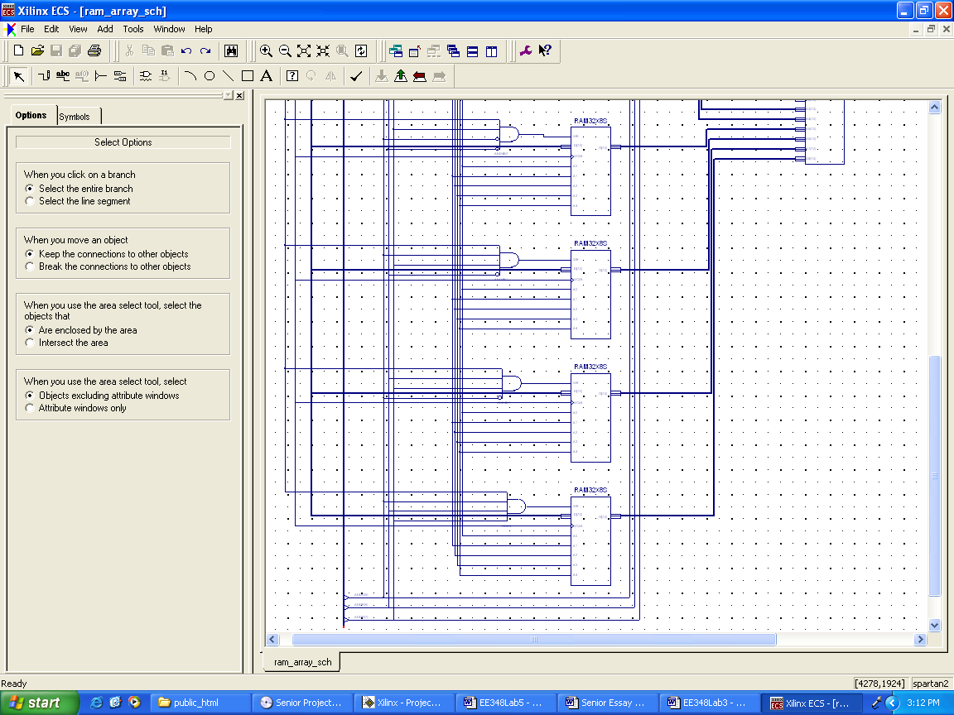
Bottom half of the RAM array
- Again, remember that the lower 5 bits are used to locate data in a particular memory module while the higher 3 bits are used to choose a row.
- Create a symbol for your RAM array.
- (Demo 5 pts) Generate a test bench to verify the RAM is working. (Please take time to study and understand how RAM works before you start to testbench).

Part 3
Memory bootstrapping circuit (your design)

(Prelab 10 pts) At the very beginning of a program execution, we have an “initialization stage”, the entire content of ROM array needs to be copied into RAM array. In order to copy the entire contents of the 256x8 ROM array into the 256x8 RAM array, we need a memory bootstrapping circuit. This circuit consists of an 8-bit counter that serves as the address location for both the ROM and RAM. 8-bit Multiplexers are wired to allow data from the ROM through to the RAM during the initialization stage, while during the rest of the program they route data in the processor (when will this happen?). The write enable signal (R/W) to the RAM is set to high both during the initialization stage as well as during a store instruction.

Memory Bootstrapping Circuit

You need to design a memory bootstrapping circuit based on general idea above. You need to first design circuits on a paper, then draw its schematics. Create a new schematic, call it mem_bootstrap for this purpose.

Part 4
Integration

In the last part, we are going to connect our memory unit to our toy processor. And we will take care of the state machine changes needed to accommodate the integration of the memory circuit into the processor.

The first state of the execution model will have to be amended so that it will not transition to the second state until the entire memory bootstrapping process (ROM → RAM) has been completed. The time for the process to complete, or the time it takes for the ROM to dump all its data into RAM, is ??? clock cycles. The completion should be signaled by an Overflow signal from the memory circuit above.

- First, you’ll have to modify your mem_bootstrap schematics to add an output pin that is high only after the ROM has been entirely read. You should figure out how to do this by yourself, it should not take long. Just remember that every time you add/remove an input/output pin from a schematic, you must re-create the symbol, as well as update it in every schematic that utilizes that symbol.

- (Prelab 10 pts) To make sure we don’t transition from State zero to State one before memory bootstrapping is complete, we have to modify the controller. The updated controller finite state machine will have to designed by you.

New Controller FSM

The updated CONTROL.v file representing this new controller needs to be designed and tested. Now you must modify toy_sch to accept an input bit called ‘Overflow’.

- Earlier, the read/write signal to the memory had only been set high (to write) when the processor was in S₄ and there was a store instruction. Now, we also want to write to memory (actually within memory from ROM to RAM) during S₀, so we add an extra OR gate in the controller circuit.

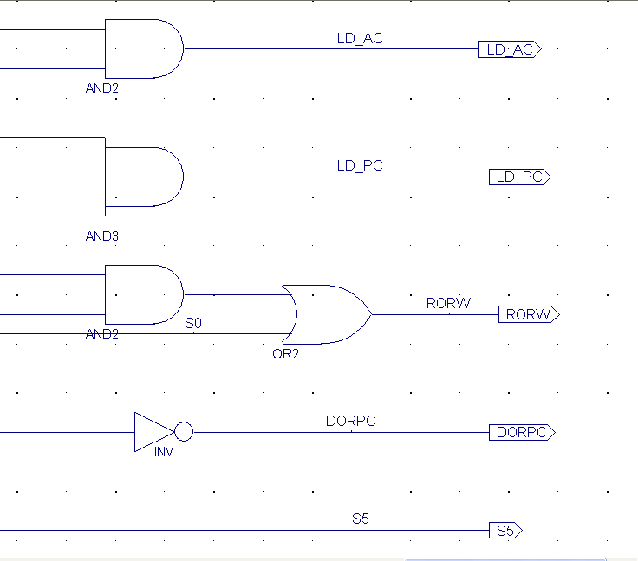
S0
Modified part of controller_sch.sch

- Add a new schematic named toyProcessor_overall.sch.
- Create symbols for your toy processor and memory unit, place them on the new schematic.
- Connect them. Note: we envision that during the zero state of our toy processor, we are going to load the program into our toy processor’s memory. More specifically, after we have our program in the ROM arrays, we load the program from ROM to RAM during state zero. For every other state, we don’t want RAM to read from ROM anymore; we want to read data from the data bus coming from the toy processor.

(Demo 20 pts) Check your overall design with testbench once you are done to make sure your design is working.

Toy processor with memory

Lab Report/Code Requirements

Lab Report Format

Each team should submit one report using the format provided below. You should provide a detailed description/discussion for each lab report item including all schematics, codes and simulation waveforms from testbench. The lab report should be in WORD or PDF format and submitted as a single file to the dropbox in ELC. Please submit your lab reports in appropriate assignment folders on ELC before the deadline. 30% credit will be taken off if the submission is late by 0-24 hours. After 24 hours, late submission will not be accepted and zero credit will be given to the lab report.

1. Student Information (First page)

Lab Number and Title:
Names of members in the team:
E-mails:
Contributions: Please list contributions (in estimated percentages) of each member in the following categories.
- Pre-lab design and analysis
- In-lab module and testbench design
- In-lab testbench simulation and analysis
- In-lab FPGA synthesis and analysis
- Lab report writing

2. Lab Purpose (Second page)
Provide a brief summary of the lab assignment.

3. Implementation Details
Provide a detailed description of the steps you followed to implement the lab. Be sure to include all relevant information. Recommended information to be included:
- Pre-lab design and analysis
- Schematics of your design if available
- Module and testbench code

4. Experimental Results
Describe the results of the lab assignment. Be sure to include any simulation waveforms for testbench. You need to summarize the simulation results, supplemented by the evidence from Screen Captures of the waveforms. Please DO NOT just copy the waveforms as the results. You need explain why they correctly verify your design. When you attach the waveform screen captures, please crop them so that the variables names, time scale and waveforms are visible in your file.

5. Significance
What is the importance of the lab? How will you use the information you learned in this lab in the future?
In which applications you can use this information?

6. Comments/Suggestions
Please provide any comments or suggestions you may have for this lab assignment. Please indicate any areas of difficulty you encountered for this lab assignment.

7. Additional Lab Specific Information
Attach any additional information requested for this lab, including schematics, simulation waveforms, or manually performed tasks.
Grading Policy
Only one copy of the lab report from each team is needed. The grade for the report will apply to both team members, provided that each team member contributes roughly equally (50/50 – 40/60) to the lab. In the case where one team member contributes disproportionally lower to the lab, the instructor may reduce the grade of this member. Late submission after due date will receive partial credits (70% of credit for 0-24 hours late submission, no credit for more than 24 hours late submission).
Plagiarism: If plagiarism is found in reports, all of them will get ZERO points immediately, and face serious consequences.

